Store Management System- User Stories

Iteration 1

1. As a cashier I want to be able to checkout

2. As Manager I want to be able to update inventory.

Use case: checking out as cashier

steps:

1: display main screen

2: Insert drawing of main screen, inventory, etc.

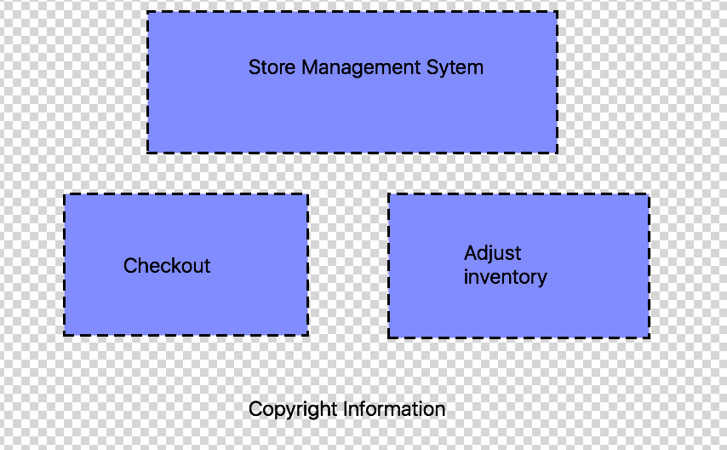

When the checkout box is clicked on, the checkout process would look like this:

Clicking start over would clear every item from the table

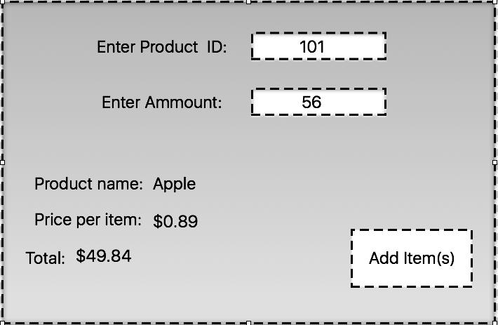

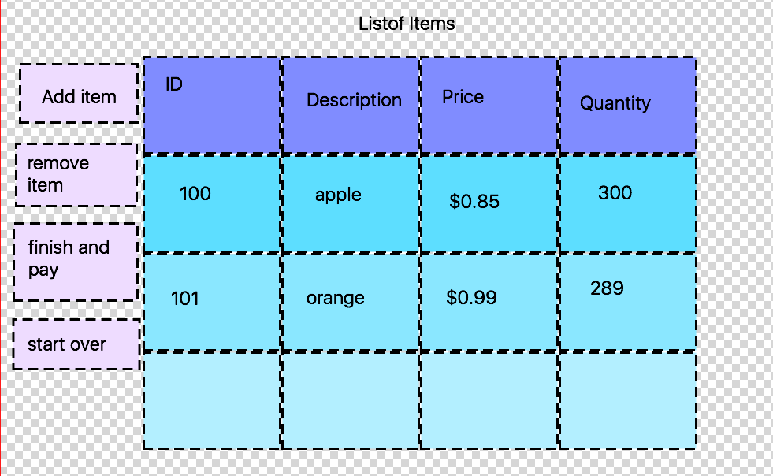

When client wants to add a new item, they will click add item and the following screen will show. They can enter the id and the amount that is being bought. Then the name of the product and the price will appear and the total is being generated live. When they are ready to confirm they click add item. If he wants to use a barcode reader this information will fill itself out

How to remove an item. They click on “remove item” and are presented with the following screen.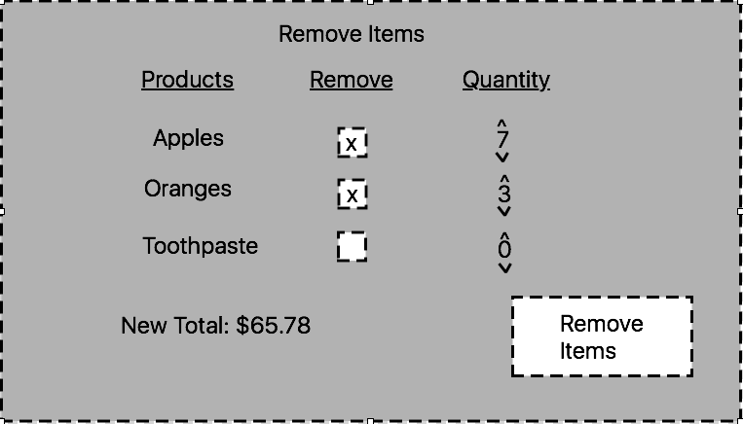

They select which items they want to remove, how many. The new Total price is displayed, they click remove items to confirm.

How to pay, client clicks the finish and Pay button and is presented with the following screen, which they select what type of payment method and are presented with another screen based off the method:

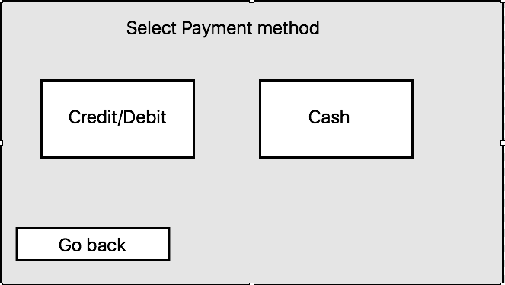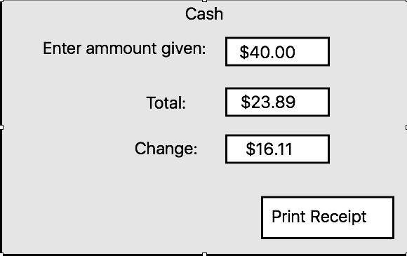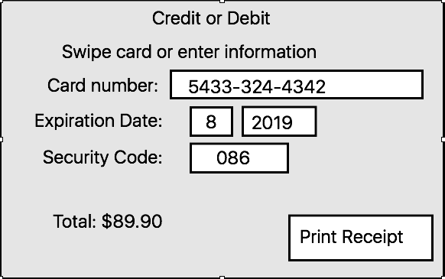

Then a window will pop up showing the information the receipt will have: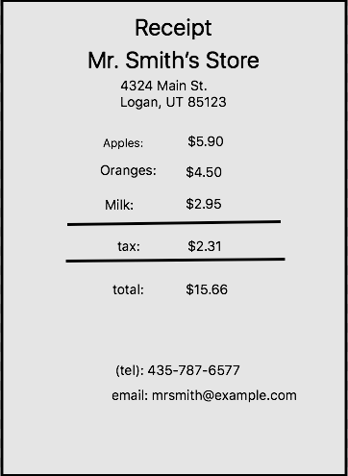

Backlog

1. As employee I want to be able to login and logout
2. As a manager I want to be able to change the price of items, add items, etc.
3. As manager I want to update inventory
4. As a manager I want to be able to correct current checkout process
5. As a customer support employee, I want to help customer return item bought previously
6. As a customer I want to be able to check out myself
7. As employee I want to be able to validate inventory
8. As customer I want to check price of item and availability
9. As customer I want to get cash back option
10. As manager I want to have daily, weekly, monthly and yearly report of earnings and losses
11. As a manager I want to be able to check integrity of cashier (money in till matches what was sold)
12. As a manager I want to get reports on availability of products
13. As manager be able to see shift time
14. As a manager I want to be able to create accounts for employees
15. As employee I want to be able to update my login information
16. As customer I want to be able to order online, and have them shipped to my address
17. As customer I want to be able to order online and pick up at the store